# CS 255 System Design Document

This template lays out all the different sections that you need to complete for Project Two. Each section has guidance to prompt your thinking. You will need to continually reference the interview transcript as you work to make sure that you are addressing your client’s needs. There is no required length for the final document. Instead the goal is to complete each section based on what your client’s needs are. Remove this note when you are finished, and replace all bracketed text with the relevant information.

## UML Diagrams

### UML Use Case Diagram

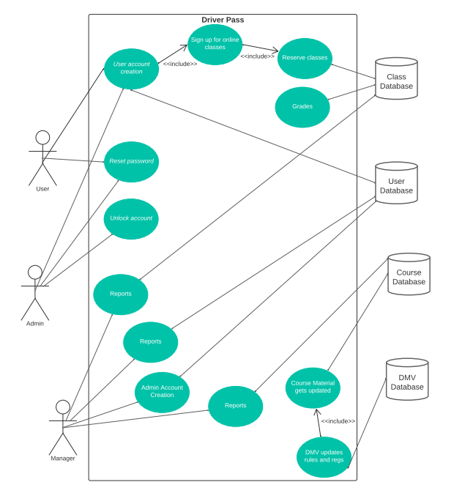

### UML Activity Diagrams

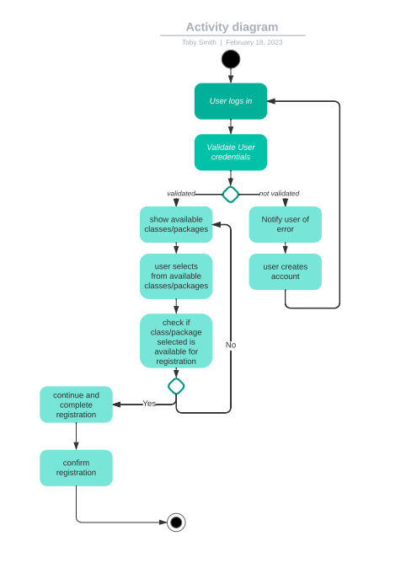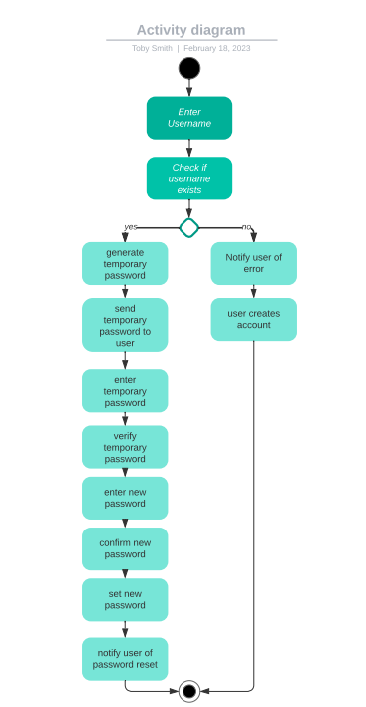

### UML Sequence Diagram

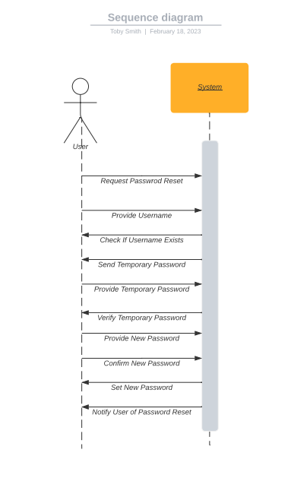

### UML Class Diagram

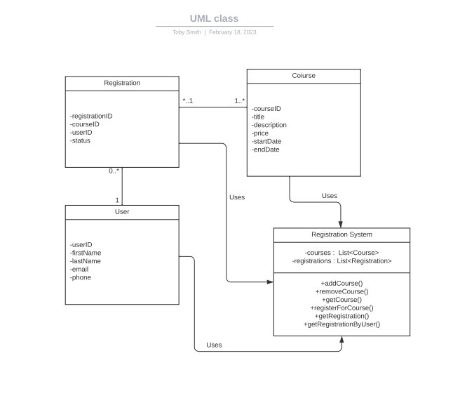

## Technical Requirements

One technical requirement for the system will be databases for the customers and DMV updates. Another requirement for the system will be servers with data and duplicated data. Another requirement is that it must be a web-application that will be hosted on the cloud. Another requirement is that it must run on windows based machines. There will be a ticket like tool that will assist with scheduling and tracking of customers that have upcoming courses/reservations. It must use secure ports for data transfers such as HTTPS. We also need account/login verification.